ГУО «СРЕДНЯЯ ШКОЛА № 6 г. ЖОДИНО»
РАЗРАБОТАНО УЧИТЕЛЕМ АНГЛИЙСКОГО ЯЗЫКА КВАЛИФИКАЦИОННОЙ КАТЕГОРИИ «УЧИТЕЛЬ-МЕТОДИСТ» КОЛЕДА СВЕТЛАНОЙ МИХАЙЛОВНОЙ

FORM 3 / TERM IV
UNIT VIII
1. | 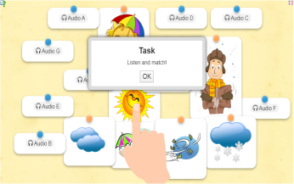 | Teaching new vocabulary. The weather. (listening) https://learningapps.org/4825093
2. | 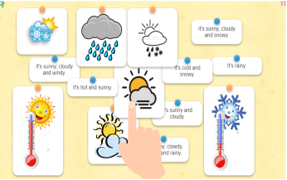 | Describing the weather. (reading)  https://learningapps.org/4879776
3. | 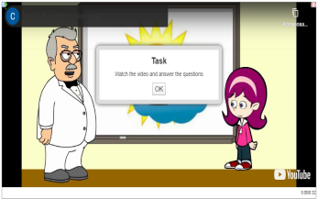 | What’s the weather like today? (video-model) (speaking) https://learningapps.org/4885846
4. | 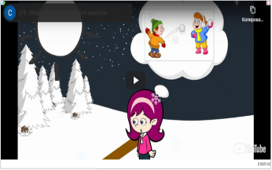 | What can you do in different seasons? (video-model) https://learningapps.org/4885855
5. | 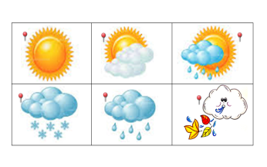 | Describing the weather. (reading) https://learningapps.org/4913147
6. | 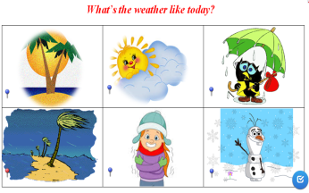 | What’s the weather like today? (reading / speaking)  https://learningapps.org/4913160
7. | 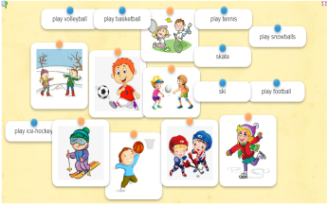 | Teaching new vocabulary. (reading)  What can you do?  https://learningapps.org/4982945
8. | 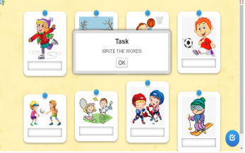 | Teaching new vocabulary. (writing)  https://learningapps.org/5023385
9. | 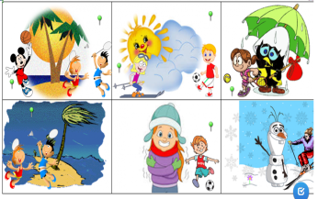 | What can you do when it’s snowy? (speaking / reading)  https://learningapps.org/5023492
UNIT IX
10. | 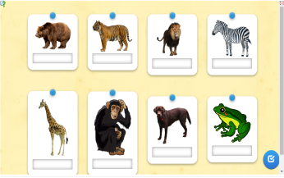 | Teaching new vocabulary. (writing)  https://learningapps.org/5044908
11. | 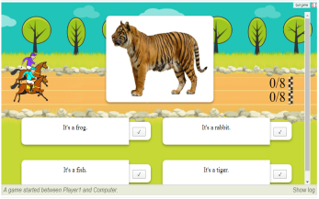 | Do you know animals? (speaking)  (a game)  https://learningapps.org/5044915
 | 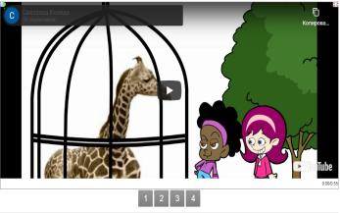 | Speaking about the animals at the zoo. (video-model)  https://learningapps.org/3462961
12. | 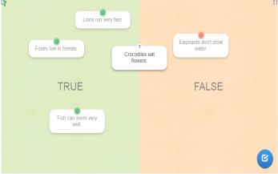 | What can animals do? (reading)  (true / false)  https://learningapps.org/3448914
13. | 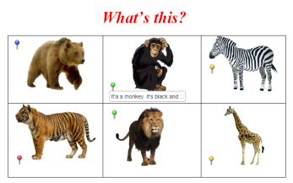 | What animal is it? (speaking / reading) https://learningapps.org/5052719
14. | 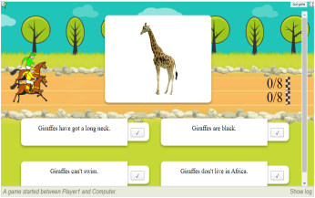 | Speaking about animals. (reading)  (a game)  https://learningapps.org/5073959
15. | 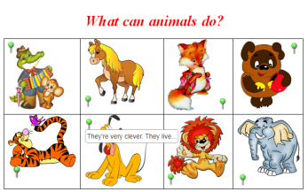 | What can animals do? (speaking / reading)  https://learningapps.org/5073973
16. | 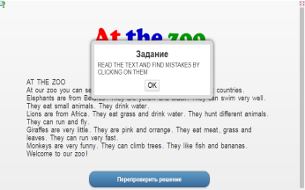 | Read the text and find mistakes by clicking on the incorrect words.  https://learningapps.org/3454716
17. | 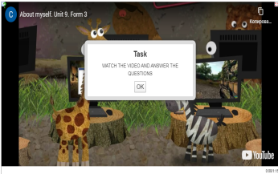 | Describing animals. (video-model) (listening)  https://learningapps.org/3380956
18. | 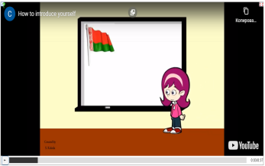 | My video passport. (video-model) (listening) https://learningapps.org/3462974
FORM IV / TERM IV
UNIT VIII
1. | 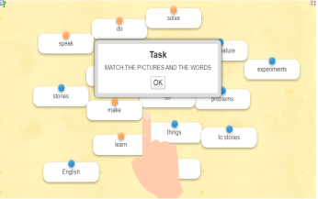 | Teaching new vocabulary. (matching pairs)  https://learningapps.org/7074716
2. | 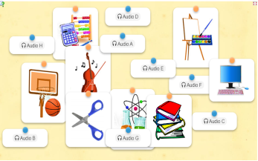 | Subjects we study at school. (listening)  https://learningapps.org/8401814
3. | 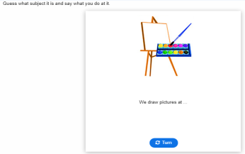 | Say what you do at different subjects. https://h5p.org/node/763184?feed_me=np
4. | 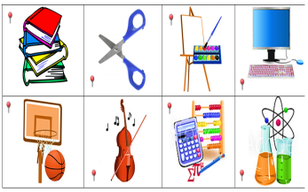 | What we do at the lessons. (reading / speaking)  https://learningapps.org/8401824
5. | 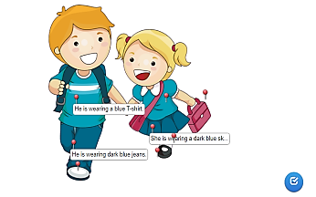 | What is he / she wearing? (grammar) https://learningapps.org/8411480
6. | 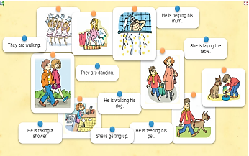 | What are they doing? (reading) https://learningapps.org/8411489
7. | 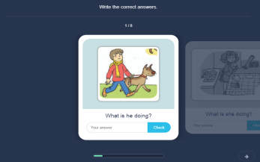 | What are they doing? (writing) https://h5p.org/node/763070
UNIT IX
1. | 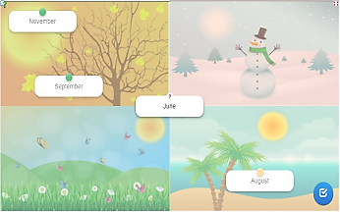 | Do you know seasons and months? (vocabulary) https://learningapps.org/8411507
2. | 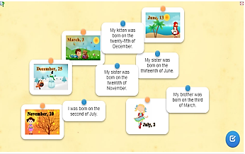 | When were you born? (reading) https://learningapps.org/8411527
3. | 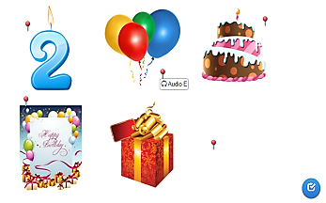 | Birthday party (words) (listening) https://learningapps.org/8438628
 | 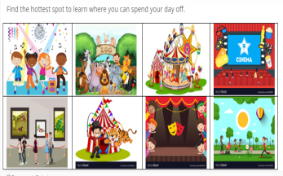 | Where we can spend our day off. (a game - hotspots)  https://h5p.org/node/763223
4. | 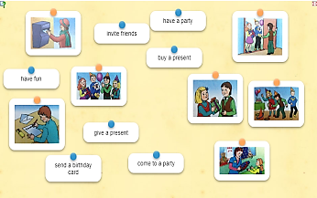 | Come to my birthday party. (vocabulary) https://learningapps.org/8438601
5. | 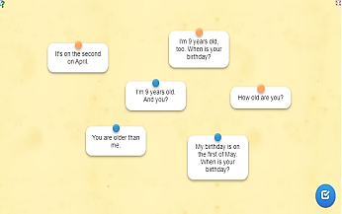 | Come to my party. (speaking) https://learningapps.org/8438604
6. | 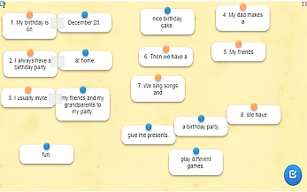 | How I celebrate my birthday party. (speaking) https://learningapps.org/8438612

